**Lincoln Heritage Council**

**Haunted Woods**

**October 25-27, 2024**



**Pfeffer Scout Reservation**

**1531 Cross Rd**

**Benton KY 42025**

Table of Contents:

Map and Directions to Camp 3

Event Contacts 3

Schedule/arrival and check in 4

Fee Schedule/Refund Policy 5

Unit Preparation for Camp 6

Camp Policies and Procedures 7

Camp Emergencies 9

What to Bring to Camp 10

**Map and Directions to**:

Pfeffer Scout Reservation

1531 Cross Rd

Benton KY 42025

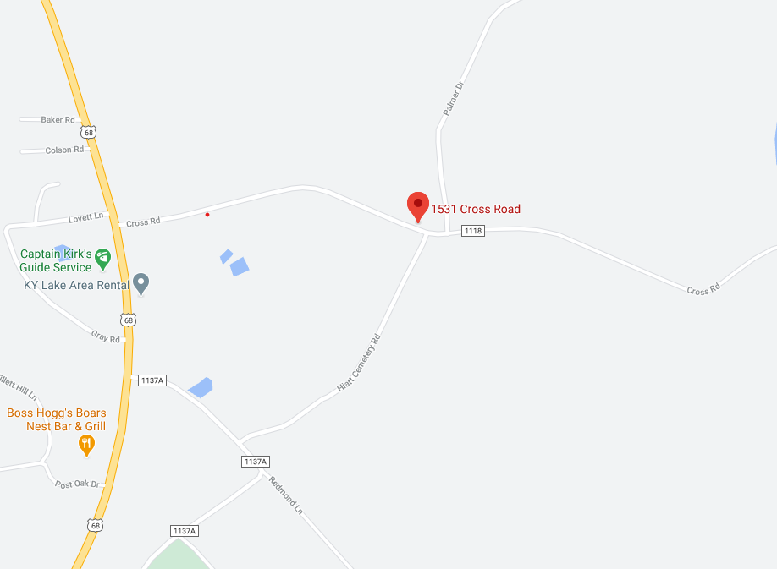

Pfeffer Scout Reservation, from Louisville take I-64 East then take gene Snyder South to I65 S follow 65 until you exit on Western Kentucky Parkway, I69 S and I24 W to US 68 in Marshall County. Take exit 47 from 69, follow US68 to Cross Rd.

**Event Contacts:**

***Lloyd Baker****, Event Chair*

[*lloydscouting@gmail.com*](mailto:lloydscouting@gmail.com)

***Maegan Blodgett,*** *Four Rivers District Executive*

*maegan.blodgett@scouting.org, 402-469-6169*

Event Schedule

* **Friday, October 25th**
  + 5:00-8:00 PM Participant arrival/check-in at Admin Building
  + 8:30 PM Leader’s Meeting (SM/CM/SPL): Admin Building
  + 11:00 PM Lights Out
* **Saturday, October 26th**
  + 6:30 AM to 7:30 AM – Arrival/Check In at Admin Building
    - *Access via vehicle from main parking lot will be closed at 7:30am*
    - *All vehicles need to be returned to main parking lot by 8:00am*
  + Breakfast in campsites
  + 8:30-8:45 AM Opening Flag Ceremony
  + ACTIVITY SESSIONS:
    - 9:00 AM – 12:00 PM
      * Activity Stations
    - 12:00 – 1:00 PM Lunch, not provided
      * In campsites or at last activity station
    - 1:00 PM – 3:00 PM
      * Activity Stations
  + 6:00 PM DINNER in Campsites
  + 11:00 PM Lights Out
* **Sunday, October 27th**
  + Breakfast in campsites, All units pack-up and begin voyage home by 10:00 AM
    - Clean and pick-up areas before departure
    - Check-out with the Campmaster or Event Staff

# Arrival & Check-In

Units may start arriving Friday, October 25th after 5:00 PM. Plan to check-in at the Administration Building upon arrival. Cub Scouts who choose to camp can be assigned a site with a linked troop or another pack. If you have a preference please indicate on your registration. All units will be on a site with another unit due to camp size and participation.

** Campsites will be emailed to all unit leaders.

**Saturday October 26th Arrival & Check In**

Vehicles will be permitted to enter camp Saturday morning until 7:30am. All vehicles need to be returned to the main parking lot by 8:00am to ensure the safety of scouts prior to programing starting.

**Fee Schedule/Refund Policy:**

**Fee Schedule: All fees should be paid based on the following information:**

Please complete the event registration link: https://lhcbas.org/event/2024-psr-haunted-woods/

**Cost:**

**$15.00 Day Only**

**$20.00 Camping**

**$10.00 per Adult**

**Adventure Tickets-FREE for the whole family**

Walk In Registration at Administration Building

**Refunds:** A refund will be made to an individual or group that cancels program attendance/registration, less a 15% administrative charge as long as a written request is made at least 30 days prior to a council or district program/activity.

No refunds will be given to an individual or group that cancels program attendance/registration within 30 days of a scheduled council or district program/activity. Exceptions for medical situations or family emergencies can be made but must be submitted in writing within 7 days after the program/activity.

Fees are transferable to other scouts but not refundable. All requests for refunds must be submitted in writing with a copy of the receipt or cancelled check.

Unit Preparation for Camp

If your unit follows the steps listed below, the process of preparing everyone for an enjoyable experience at Pfeffer Scout Reservation should go smoothly.

Upon Receiving the Leaders Guide:

* Inform or remind all Scouts and parents of the Camp Dates.
* Recruit two or more adult leaders to spend the weekend with your unit.
* Note payment dates to ensure your troop gets the early bird discounts.
* Make arrangements for physicals to be done if they are not current.

Finalizing plans for the outing:

* Give final notice to all scouts and parents about plans for attending camp.
* See that all Scouts and Adults have a current medical form.
* Arrange for your transportation to and from camp.
* Insure all your Scouts families have the information on the weekend.
* Register online at [www.lhcbsa.org](http://www.lhcbsa.org) or send registration form and fees to the Scout Service Center.

One week before Camp:

* Review Schedule with your Scouts and families.
* Double check medical and health history.
* Prepare the unit/patrol equipment to bring to camp.
* Inspect each Scouts personal gear- be prepared for all types of weather!
* Finalize Transportation arrangements to and from camp.

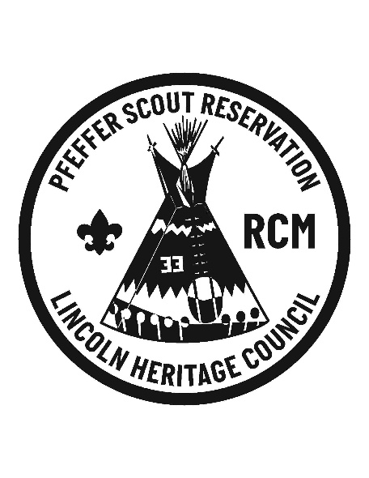

**The Camp Policies and Procedures:**

Anyone participating in this event will be expected to follow BSA National Guidelines as outlined in the Guide to Safe Scouting.

**The Law is the Rule**: Everyone is expected to abide by the Scout Law, Oath, Slogan, and the Venturing Code.

**Buddy System**: Everyone will use the Buddy System. Pairs for Safety. Adults/ Leaders should be notified before Scouts leave their campsites.

**Camp Security:** All visitors to the camp must stop at the camp office and sign in. A sign-in book for this will be maintained and positive identification is required. A visitor name tag will be given. Upon conclusion of their visit, guest will sign out so that camp administration will know who is on camp property at all times.

**Alcoholic Beverages**: This will not be tolerated and is against BSA policy. Possession or use will result in immediate dismissal from camp.

**Smoking:** An important way adult leaders can model healthy living is by following the policies on alcohol, tobacco, and drugs. Leaders should support the attitude that they, as well as youths, are better off without tobacco in any form and may not allow the use of tobacco products at any BSA activity involving youth participants. This includes the use of electronic cigarettes, personal vaporizers, or electronic nicotine delivery systems that simulate tobacco smoking.

All Scouting functions, meetings, and activities should be conducted on a smoke-free basis, with smoking areas located away from all participants.

As outlined in the Scouter Code of Conduct, Scouting activities are not a place to possess, distribute, transport, consume, or use any of the following items prohibited by law or in violation of any Scouting rules, regulations, and policies: alcoholic beverages or controlled substances, including marijuana.

In addition, the Code of Conduct specifies that if you are taking prescription medications with the potential of impairing any functioning or judgment, you will not engage in activities that would put Scouts at risk, including driving or operating equipment.

**Vehicles**: The health and safety committee along with the camping committee has established a written policy and procedure of vehicles in camp. Unload and set up camp as quickly as possible, then return your vehicle to the Main Parking Lot. Each unit may leave one equipment trailer with attached vehicle at the campsite. The roads must remain clear for emergency vehicles and event activities. Park your vehicle temporarily on the road and unload from there, do not drive into campsites.

* NO vehicles will be allowed to remain in campsites without pre-approval from camp administration.
* Weather permitting, trailers will be allowed in campsites. However, vehicles used to pull trailers need to be moved back to designated parking lots.
* 3 MPH (Walking speed) speed limit.
* One person per seatbelt and they must be worn. No riding in truck beds. No RV’s, ATV’s, golf carts or generators. Only Staff carts are permitted.

**Parking**: Park in designated parking areas only. Unit leaders need to help enforce this policy. We need to help preserve Camp.

**Uniforms:** We ask that all Scouts be in Field (class-A) Uniform for Campfire Program. Scouts are free to wear whatever their unit has approved as an Activity Uniform throughout the remainder of the weekend. The Council Elders have decreed that PROPER VIKING ATTIRE will substitute for scout uniform (and may garnish accolades during the day’s challenges). Beards are encouraged!

**Stoves and Lanterns**: Follow BSA regulations according to fuels. Keep open flames out of and away from tents.

**Camp: Follow BSA guidelines for camping.**

* Walk, do not run, within your campsite.
* Remember tent stakes and tie downs.
* Closed toed shoes must be worn at all times.
* Stay out of the creek if you are in or near old camp.
* Fish may be taken with a hook and line only.
* Do not ditch or trench your tent.
* Leave no Trace.
* Trash your trash. It should be removed from all campsites.
* No pets or bikes.

**Campsites:** Do not cut trees. Bring your own firewood, charcoal or collect dead wood from the downed trees. No pit/trench fires use fire rings provided. Never leave a campfire unattended, especially when going to bed. ***All campfires should be extinguished according to BSA guidelines.*** Please make sure before leaving on Sunday that your campsite is completely cleaned up and all campfires are completely extinguished.

**Knives, Hatchets, Axes, Chainsaws or Firearms**: No firearms are permitted at Camp. No chainsaws are permitted. No fixed blade, sheath or survival knives are permitted. Folding or pocketknives are permitted by those Scouts that have earned their Whittlin’ Chip or Toten Chip. Axes and Bow Saws are only permitted in axe yards of Scout BSA Troops / Venture Crews.

**Rocks and Sticks**: Although tempting, rocks must not be thrown or kicked and sticks may not be swung. Injury/damage to property usually results from this action. Such actions will result in your being asked to leave the campout immediately.

# First Aid: The Health officer will be on site during the activity. Medical Emergencies should be directed through them. Units are responsible for assuring/handling all medical forms (A and B). In case of emergency notify the Camp Ranger and/or Campmaster on site.

If anyone in your crew has medical limitations/food allergies that could affect their ability to camp and participate in the activities, please contact the event organizers ASAP.

**Trash:** Your trash must be taken to a dumpster. No trash should remain in campsites over night; there are skunks and raccoons that will visit your unit if this is not done.

**Cleanup:** When your unit is ready to leave camp we ask that you please clean up your area and leave it the same or better than you found it. Please take everything with you. Trash can be dropped in the dumpster as you leave camp.

# Meals: Units/individuals will be responsible for all meals of the event.

**Camp Emergencies:** With the exception of the weather emergency, all campers are to report immediately to their campsites upon hearing an emergency signal. In the case of a weather emergency, campers should seek protective shelter. Once the weather emergency has passed, campers should report to their campsites. Campers should remain in the campsites until the “All Clear” signal has been given. Leader should review these procedures with their campers.

***The following emergency signals will be used:***

Fire Alarm: Sound the siren (two long blasts).

Weather Emergency: Sound the siren (one long blast).

All Clear: Sound the siren (four long blasts).

**What to Bring to Camp:**

*Personal Gear:* Please distribute copies of this page to each Scout. Camping will be in your own tents.

**(Tents will not be provided)**

Scout Uniform

Oder of the Arrow Sash (if you are a member)

Medical Form (MANDATORY)

Handbook

T-shirts

Pants

Socks and Underwear

Footwear (waterproof)

Warm Clothes

Sleeping bag

Sleeping pad (Optional)

Toilet Kit (tooth brush, towel, soap, etc)

Water bottle

Flashlight (extra batteries)

Pen and paper

Be Prepared for the weather (Continue to check the report on the news the week before you arrive)

Pocket Knife (If you have your Whittin Chip or Toten Chip card)

Watch (Optional)

Sunglasses (Optional)

Tent (If your unit doesn’t have one for you)

*What not to bring to Camp:*

Bikes

Roller Blades or Skates

Skateboards

Sheath Knives

Butterfly Knives

Fireworks

Electronic devices (Smart Phones, video games, etc.)