Boy Scouts of America, Youth Protection Overview 12-18-23

Youth Protection Training for Adults & Youth:


New to Scouting? Click here to login and take Youth Protection training. You do not have to be a registered member of the Boy Scouts of America to take Youth Protection training.
To take Youth Protection training go to My.Scouting.org and create an account. You’ll receive an email notification with your account information, including a member ID/reference number.

YOUTH PROTECTION RESOURCES FOR PARENTS:

How to Protect Your Children From Child Abuse: A Parent’s Guide
A booklet, included in the printed handbooks, providing tips to help parents talk with their sons about child abuse.
Booklet – English Booklet – Español
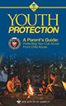

BSA – Specific Older Youth Programs/Support:
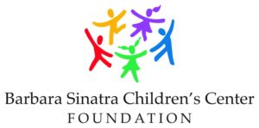
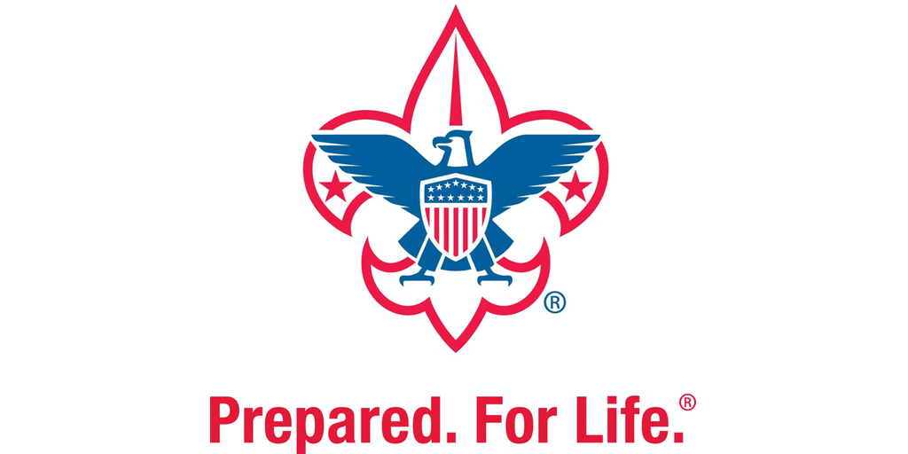


The Boy Scouts of America is committed to creating safe environments for Scouts and leaders. Child abuse is an uncomfortable topic but an important one for us to cover to ensure the safety and well-being of our Scouts. The Boy Scouts of America has partnered with subject-matter experts from the Barbara Sinatra Children’s Center Foundation to present the Personal Safety Awareness Series. The Personal Safety Awareness Series main goal is to educate teens about what to do if they experience abusive behavior, educate them about safe and unsafe touches, and encourage them to go to a parent or another trusted adult for help.
Personal Safety Awareness Video Series:
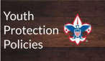




ADDITIONAL VIDEOS:
Persistence for Pictures
Grooming & Sexual Abuse
Sexual Abuse in the Family
Friends Should Never Look the Other Way

Guide to Safe Scouting: Rules & Regulations for age appropriate Scouting activities.
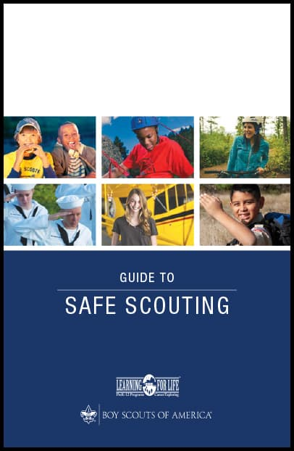

Suicide Prevention Training: Download the Discussion Guide

Camp Leadership … A Guide for Camp Staff and Unit Leaders:
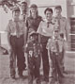

Cyber Chip (for all ages):
To help families and volunteers keep youth safe while online. Topics include cyberbullying, cell phone use, texting, blogging, gaming, and identity theft.
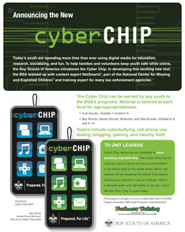
.

Bullying Awareness
The idea that a Scout should treat others as he or she wants to be treated—a Scout is kind—is woven throughout the programs and literature of the Boy Scouts of America. When a Scout follows the principles of the Scout Oath and Scout Law, bullying and hazing situations should never occur. These fact sheets will help with bullying awareness and direct you to resources provided by the BSA and other entities we work with to protect children.
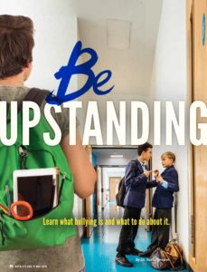
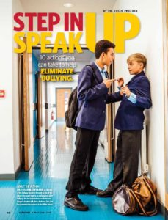
Step In Speak Up

Be Upstanding

Other Bullying Resources:
A Scout Is Kind Newsletter
Bullying—What is Bullying?
Bullying Prevention Guide
Creating a Bullying-Free Culture in Scouting
What to Do if Your Child Is Being Bullied
Prevention of Cyberbullying in Scouting
Reporting Suspected or Observed Bullying
Providing Support to Scouts Who Are Bullied
The Bully
Prevention of Bullying in Scouting—Unit Discussions
Myths About Bullying

