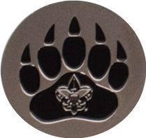
Lincoln Heritage Council
Kodiak Challenge
November 3-5, 2023
Camp Lowe - Harry S. Frazier Scout Reservation
Shepherdsville, KY

Calling all Venturers and Scouts 14 or older! Are you looking for a chance to put your skills learned at ILSC, ILST, or NYLT into practice? We have a great opportunity for you coming this Fall at Camp Lowe – Harry S. Frazier Scout Reservation in Shepherdsville, KY.

This year the KODIAK CHALLENGE course will provide you with the opportunity to hone your skills in a unique Challenging Outdoor Personal Experience (COPE).

Kodiak presents 5 challenges during the course that focus around leadership skills and team building exercises that will occur as we Traverse the COPE Course at CCC.

We are currently accepting registrations for this Fall course. (Paper registrations are always accepted. Online registration will be coming soon to https://lhcbsa.org/kodiak-challenge/) Additional information about when to arrive, the expected end of course, and what to bring will be e-mailed to each registered participant. Course is limited to 32 participants.

For parents/guardian/leaders that may be accompanying Scouts/Venturers, camping will be available at Camp Lowe. Non-participants can provide their own meals and cooking supplies for the weekend or pay the special price and attend meals with the participants and staff.

Looking to support the Kodiak Challenge? We have a limited-edition Lincoln Heritage Council Strip Patch available for purchase. Every purchase will help to fund scholarship assistance for Scouts to attend this and future courses! Quantities are limited.
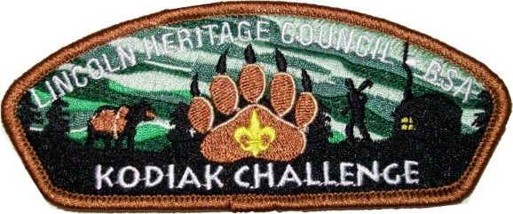

Cost:

$60.00 per participant
$30.00 per non-participant
$10.00 per limited edition CSP
New Design to be announced

Contact Information:
Kent Burton, Course Director  502-387-5234  kent.burton@protonmail.com | Thomas Geary, Director of Camping  502-361-3783  Thomas.Geary@scouting.org

Registration information on back

Complete the registration form and send to the Sam Swope Scout Center:
Attn: Kodiak Challenge
12001 Sycamore Station Place
Louisville, Kentucky 40299
Phone: (502) 361-2624 Fax: (502) 361-7899
Registration is available online at https://lhcbsa.org/kodiak-challenge/

2023 Fall Kodiak Challenge: November 3-5
Youth Name(s)
1
2
3
4
5
6
7
8
9
10
11
12
13
14
15

COST: $60.00 per participant

Limited Edition CSP: $10.00 per Patch

Unit Type: Troop #:_________ Crew #: __________

Council: ______________________ District: _________________

Scouter Completing Form: ________________________________

Mailing Address: _______________________________________

CITY: ___________________ STATE: ______ ZIP: __________

PHONE: ______________________________________________

EMAIL: ______________________________________________

TOTAL YOUTH: _________ X $60.00 = _______________
TOTAL NON-STAFF ADULTS: ______ X $30.00 = _______
TOTAL LIMITED EDITION CSP: _____ X $10.00 = _______
GRAND TOTAL: __________________
Fax this in:
502-361-7899

Email this in:
Jessica.Smith2@scouting.org
METHOD OF PAYMENT: ______________________
(Credit Card, Check, Cash)
Name on Credit Card: _______________________________
Billing Address: _____________________________________
City: _____________________ State: _________ Zip: _______
Amount to be charged: $______________________________
Credit Card Number: _________________________________
Card Expiration Date: ________________________________
CVC (Code on back of card): ____________

Account number:
1-6801-291-20

Any Questions? Contact:
Kent Burton
502-387-5234
kent.burton@protonmail.com

